**Record Class:**

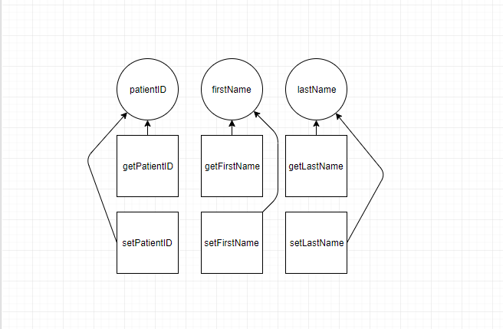

LCOM4 = 3

This class has 3 attributes with a getter and setter each with no common dependencies

Bad

**Schedule Treatments Class:**

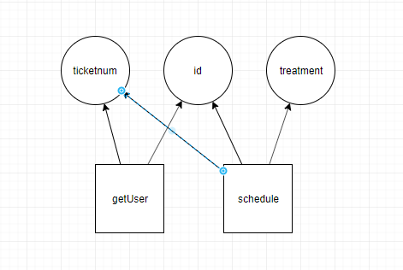

LCOM4 = 2

Both methods rely on id and ticketnum

Good

**View Treatments View Class**

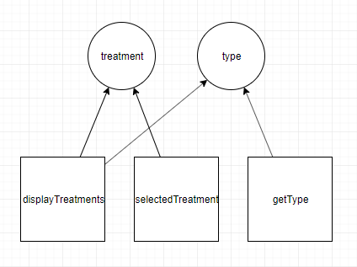

LCOM4 = 2

The methods displayTreatments and selectedTreatment both rely on treatment, while getType and displayTreatments rely on type

Good

**Insurance Class:**

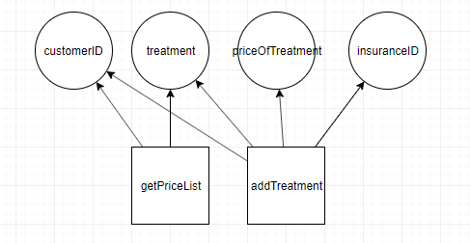

LCOM4 = 2

The methods getPriceList and addTreatment both rely on customerID and treatment

Good